I. Program Name: The Cat

II. Program Description: A program that displays a cat character on screen.

III. Input/Process/Output:

Input: None

Process: Encoding characters

Output: Display cat character on screen

IV. Flowchart:

Encoded Characters

Display cat character

V. Source Code:

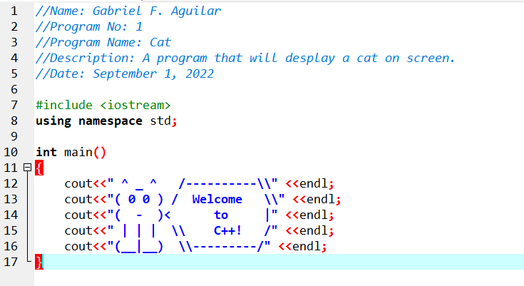

VI. Screenshot:

